Exercise Program for Shoulder

- Shoulder flexion 2. Shoulder Abduction

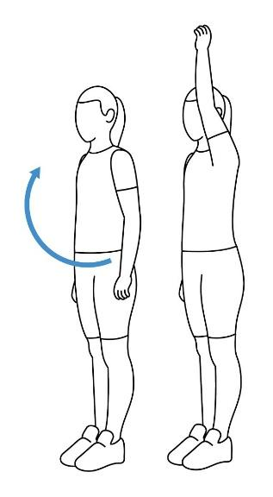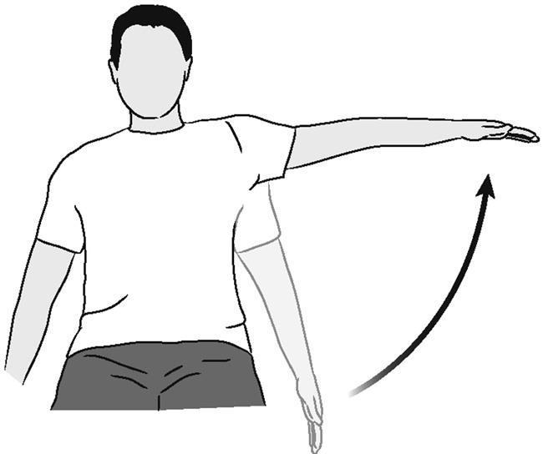

3.Shoulder Internal Rotation 4. Shoulder External rotation

