Home After the Hospital: Scar Massage

Once your stitches have been removed and scabs have fallen off by themselves, it is very important to begin daily scar massage.

Scar Massage Helps:
- Prevent scarring of tissue, or from scar tissue to “build up.” If this happens, you can have limited range of motion in the area.
- Increase the circulation of body fluids so that tissues get enough nutrition.
- Prevent scar tissue from becoming dry or splitting during exercise.

Scar Massage should be done SEVERAL TIMES EACH DAY (only after stitches are removed and the wound is not open).

How Should I Prepare My Skin?
- You can use lotion as directed by your doctor during the massage to prevent drying and cracking of the skin. It also helps to keep the scar soft.

Before your massage, you may also use
- Heat for ______ minutes _______ times in the day
- Ice for ______ minutes _______ times in the day

DIRECTIONS:
- Wash your hands before beginning
- Place lotion over the scar tissue
- Use the pads or soft tips of your fingers to massage the scar and tissue around the scar. Press firmly, but do not push until you have too much pain. Apply steady, deep, downward pressure while moving in a circular motion. Try to move the scar in each direction.
- Repeat massage for ______ minutes at least ______ times each day.

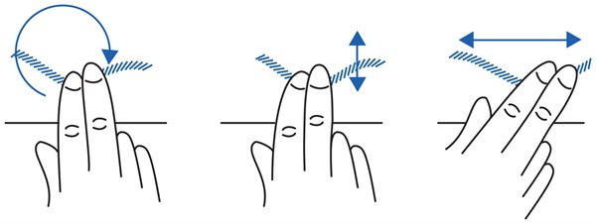

REMEMBER: Be sure the scar is moving WITH your fingers, and your fingers are not just sliding back and forth over the scar. 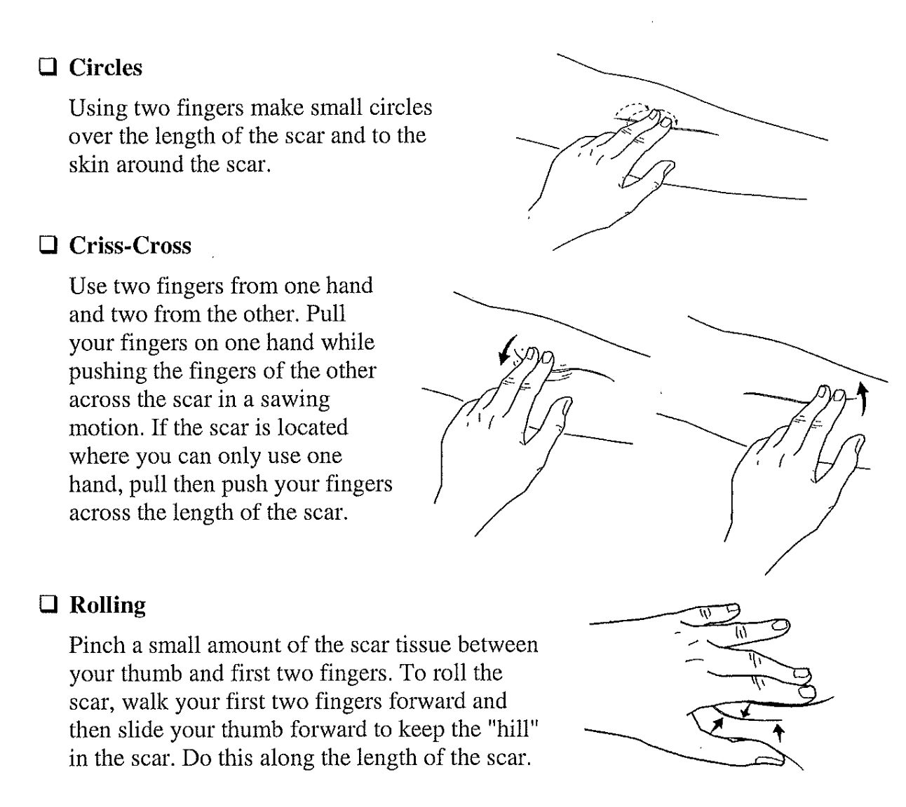

STOP The Massage and Check with Your Doctor If You Notice:
- Any redness
- Bleeding
- Moisture or draining from the scar
- The scar feels warmer than the tissue around it
- More pain at the scar

