Apraxia: OT Treatment Ideas
Jen Thompson, MS, OTR/L

OT Observations:
Ideomotor Apraxia:
- Examples:
  - Clumsy, inflexible movements that lack goal directed sequencing to hold ADL.
  - Difficulty adjusting grasp in accordance to task
  - Unable to manipulate environmental controls but understands the concept and has sufficient hand strength to perform
  - Unable to orient the upper extremity or hand to conform to object properties for grasp (ex: poor prehension for picking up a cup)
  - Unable to change an awkward grasp when holding an ADL item
  - Difficulty with orienting body in terms of directions according to intended actions (ex: turn your body” or “raise your arm” will be challenging)
  - Decreased performance quality because of inability to adjust movement during ADL
  - Utilizes inflexible and static hand patterns during ADL object manipulation
  - Difficulty manipulating small objects from palm to fingers and fingers to palm
  - Difficulty gesturing the correct use of a familiar object after command in absence of object
  - Difficulty gesturing the correct use of a familiar object after verbal command with presentation of object
  - Difficulty imitating meaningless gestures previously shown by therapist/examiner
  - Able to verbalize concepts of task; unable to execute.

Ideational Apraxia:
- Examples:
  - Demonstrates delay in initiation of task and unable to verbalize task concepts
  - Does not demonstrate appropriate use of ADL items
  - Does not appear to know what to do with ADL items presented at task
  - Utilizes body parts in place of tools during ADL task

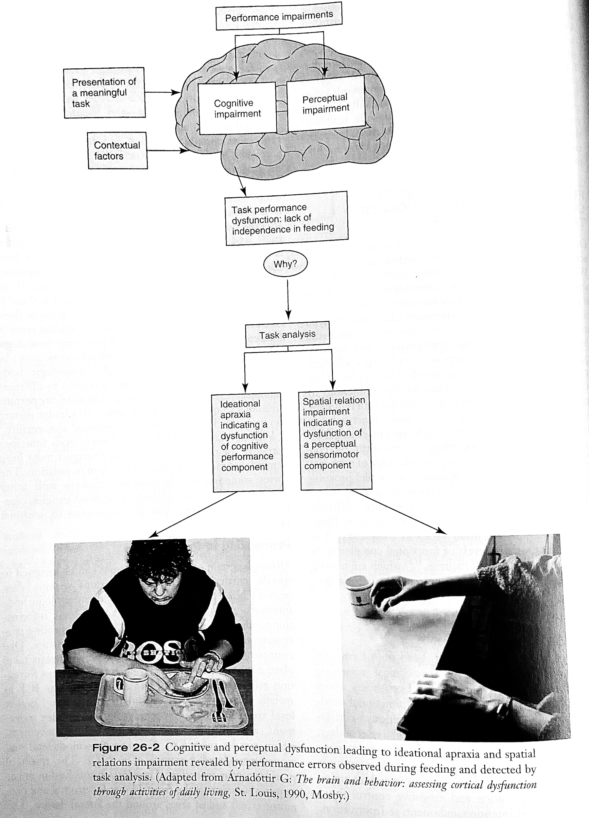
Arnadottir, G. Impact of Neurobehavioral Deficits on Activities of Daily Living, pp. 573-611. In Stroke Rehabilitation: A Functional Based Approach, 4th edition. Glen Gillen, Ed. US: Elsever, St. Louis, Missouri.

Training Ideas
- Compensatory Task Training:
  - GOLD STANDARD for patients with limb apraxia (Donkervoort et al., 2001; Geusgens et al., 2007, van Heughten et al., 1998).
  - Goal: improve functioning in spite of impairments in motor planning.
  - Determine level of deficit: initiation and orientation; execution; or ongoing control.
  - Can assess the effectiveness of this type of training using Barthel Index (pre/post)

Phase | Functions | Therapist Training and Assistance
Initiation and orientation | - Determine general plan of action  - Select appropriate object to use in task  - Determine the sequence of steps for performing the task | - Practice selecting the correct tool (from an array of three or four choices)  - Provide explicit verbal, written, or pictorial dimensions that describe goal, purpose of task objects, and steps of the task  - Alert the patient to relevant objects- by placement, pointing to appropriate objects, pictures  - Simplify activity if it’s too difficult
Execution | - Perform task in an efficient manner | - Provide explicit instructions (“try reaching this way”) through gesture, demonstration, or physical assistance  - Show pictures of each step - see below.  - Sit next to, rather than across from the person when providing demonstration  - Physical assist may require prepositioning of the limbs, guiding the limbs, and performing the steps the patient cannot yet achieve
Control and Correction | - Assess how effective performance has been  - Make necessary corrections | - Provide extrinsic feedback (assess patient’s knowledge of performance and/or knowledge of results)  - Cue person to subconsciously use senses to evaluate their result (“can you taste the toothpaste on your teeth? Can you feel the comb on your scalp? Do you see your fork, spoon and plate at the table setting?)  - Ask patient to assess his or her own performance.

- Take photos of the patient performing each step of a task (ex: making sandwich including gathering and opening all items) and use these customized photos to promote blocked practice
  - Blocked practice- efficient ADL/ IADL performance! Achieving mastery one task at a time
    - Hold practice in the actual setting that patient will be performing task. Ex- if patient shaves in the shower, practice this task at shower level rather than sitting in wheelchair at sink.
    - Best to perform ADL task at the same time that the patient performed before hospitalization- if patient showers at nighttime, practice shower level ADL at nighttime.
    - Use leisure tasks and objects that are familiar to the patient- crossword puzzles on paper vs computer/ tablet
- Errorless learning:
  - Task grading
    - Highest level of assistance: hand over hand passive cuing where OT physically guides the patient through motor learning
    - Moderate assistance: therapist demonstrates action and patient copies action immediately afterwards- do this until the patient can independently perform
      - Direct training: cue patient’s attention to each detail of task and consequences of certain actions
      - Types of cues:
        - Verbal
        - Visual
        - Tactile
      - Use concrete directions within the context of the activity - helps with increasing attendance to task.
    - Eventually fade cuing and assistance out until the patient can perform tak independently
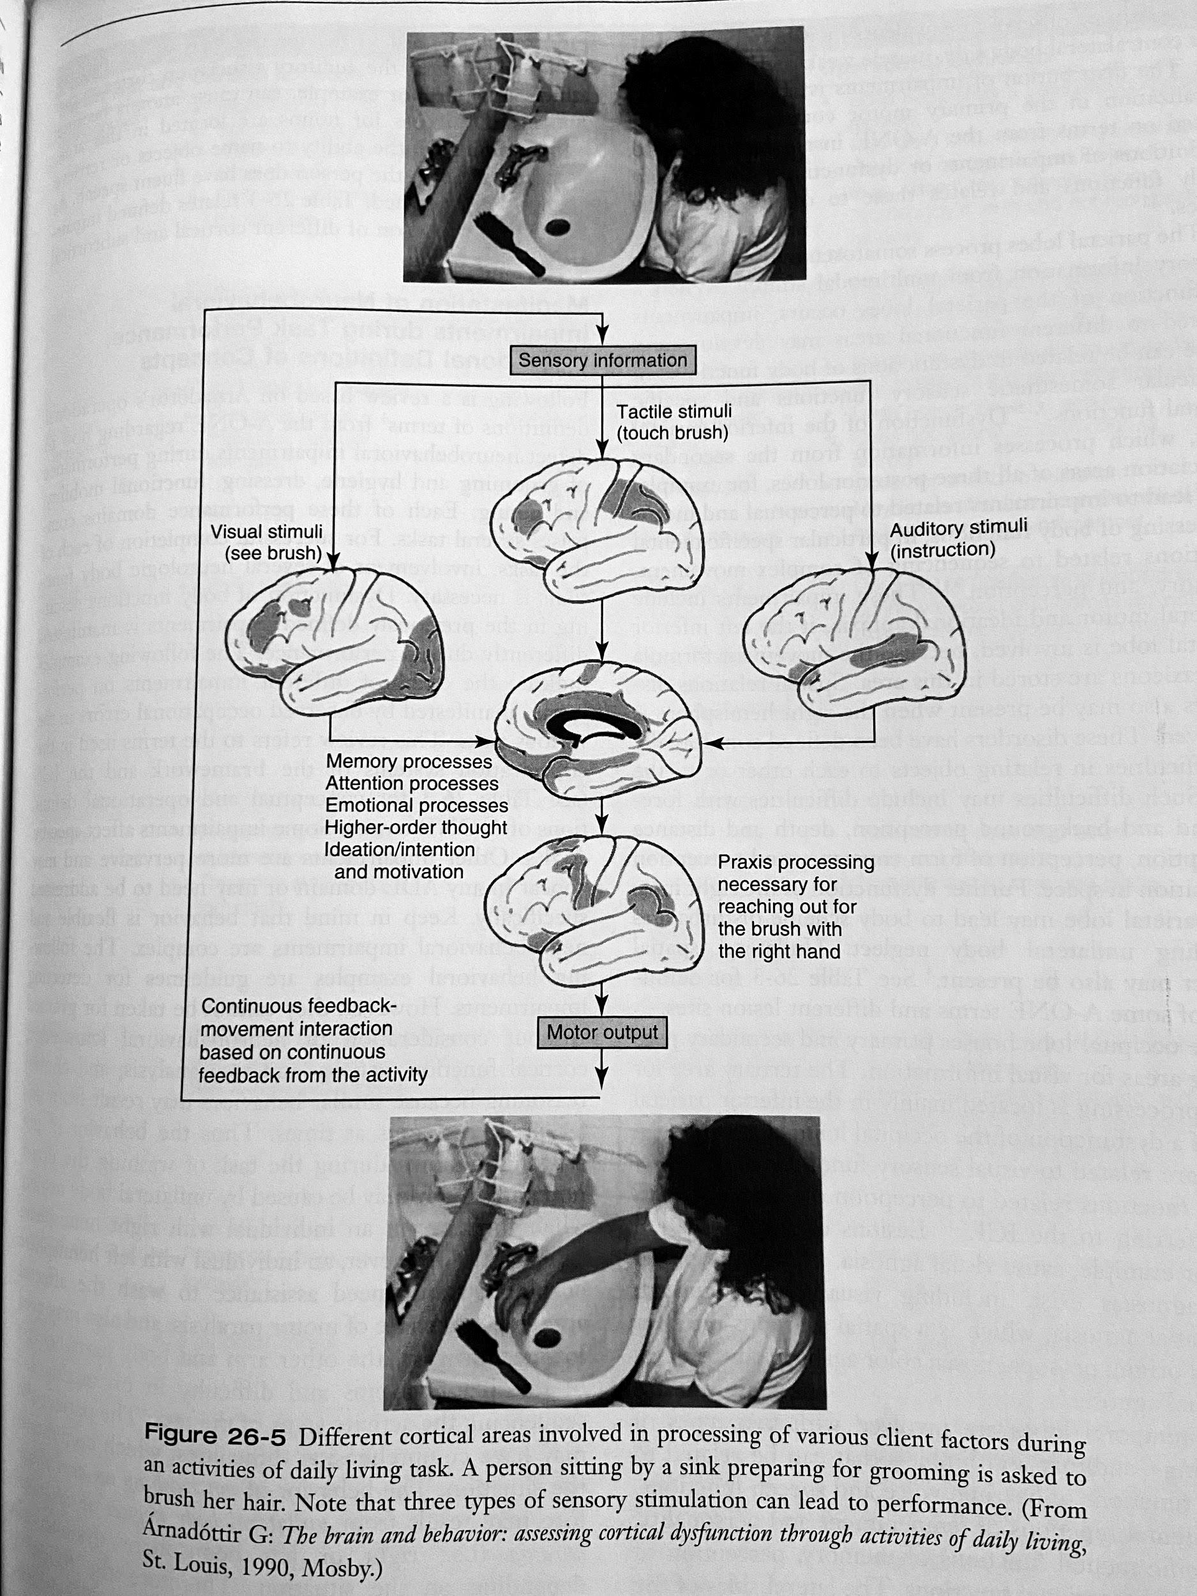
Arnadottir, G. Impact of Neurobehavioral Deficits on Activities of Daily Living, pp. 573-611. In Stroke Rehabilitation: A Functional Based Approach, 4th edition. Glen Gillen, Ed. US: Elsever, St. Louis, Missouri.

- Gesture training- grade/ adapt activities depending on patient’s understanding.
- Step 1: Hand the patient an object - keep it simple and start with items that are appropriate / familiar to the patient (ex: comb, fork).
  - Don’t use objects that aren’t familiar to the patient- for example, if the patient doesn’t cook, giving them a spatula may not set the patient up for success.
- Step 2: Show photos of the object being used in it’s intended and appropriate way. Then, have the patient pantomime using item (ex, using scissors to cut).
- Step 3: Show the patient a picture of only the object, and have the patient demonstrate using the item.
- Strategy training: compensation internally (self-verbalization) or externally (pictorial cues).
- Remove external distractors/ unnecessary environmental stimuli to reduce patient using necessary tools for ADL task

**It’s important to differentiate between apraxia and aphasia:
  - Use regular commands “show me how you would ….”
  - Questions that can be answered by yes/no responses
    - If patient can answer Y/N questions, he or she may be apraxic
  - Ability of the patient to point to the correct answers -- if the patient cannot answer Y/N questions, consider aphasia or other language deficits. Seek clarification from SLP for language impairments.

Other types of apraxia
- Buccofacial - SLP evaluates
- Oculomotor - DO (doctor of optometry) evaluates. DO to instruct OT on specialized vision protocols if applicable.

References:
Almhdawi, Mathiowetz, and Bass. Assessing Abilities and Capacities: Motor planning and performance pp.255-268. In Occupational Therapy for Physical Dysfunction, 7th edition, 2014. Radomsky & Trombly (Eds). Lippincott, Williams & Wilkins: Baltimore, MD

Arnadottir, G. Impact of Neurobehavioral Deficits on Activities of Daily Living, pp. 573-611. In Stroke Rehabilitation: A Functional Based Approach, 4th edition. Glen Gillen, Ed. US: Elsever, St. Louis, Missouri.

Hamby, J.R. Altered Mental Status, pp.595-596. In Occupational Therapy Acute Care. Helene Smith-Gabai (Eds). American Occupational Thearpy Association Inc, US: Bethesda MD.

Sabari, J.B., Capasso, N., and Feld-Glazman, R. Optimizing Motor Planning and Performance in Clients with Neurological Disorders, pp.615-656. In Occupational Therapy for Physical Dysfunction, 7th edition, 2014. Radomsky & Trombly (Eds). US: Lippincott, Williams & Wilkins, Baltimore, MD

